Building an Hello World API using Swagger in 5 steps (using Swagger Editor and Node.js + Express)

<https://www.npmjs.com/package/swagger>

You need to install swagger using npm

npm install –g swagger-editor

The API with one path (shown in Swagger Editor)

/hello

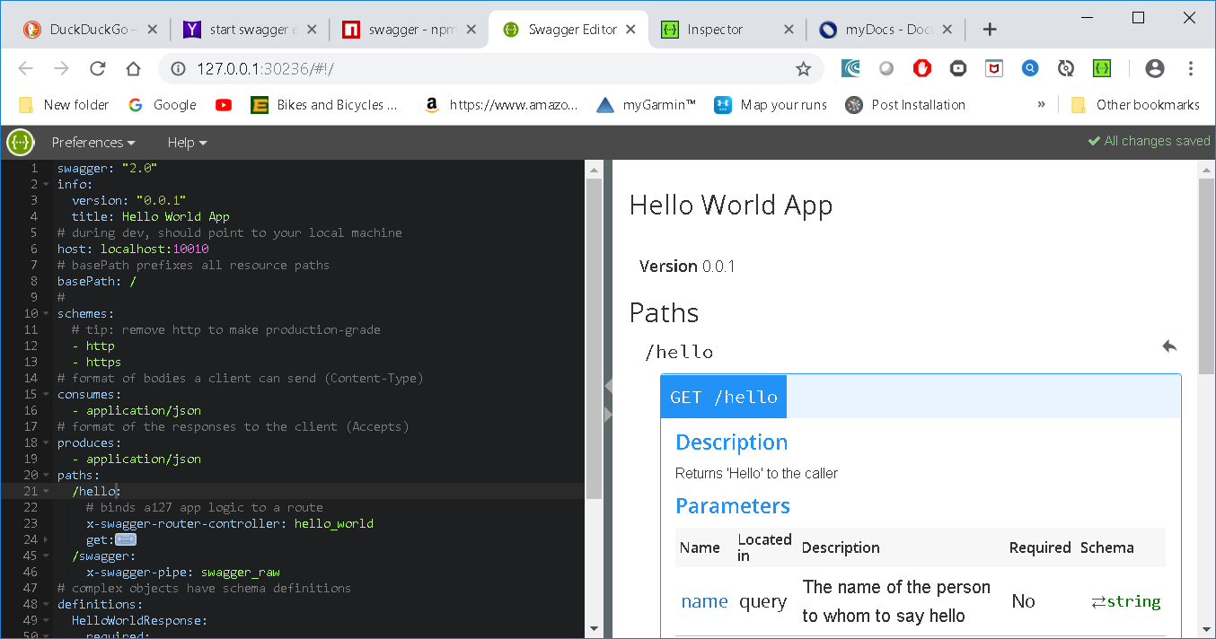

I used Swagger Inspector to call the API

